The Importance of Phonics

Phonics is the method of teaching reading and writing by correlating sounds with letters or groups of letters. There are 44 sounds in the English language which we put together to form words. Some sounds are represented by one letter like the 't' in tin, whilst other sounds are represented by two or more letters like 'ck' in duck.
Children are taught the sounds, how to match them to letters and finally how to use the letter sounds for reading and spelling.
Understanding phonics - https://www.oxfordowl.co.uk/for-home/reading-owl/find-a-book/read-write-inc-phonics--1/understanding-phonics-video

Technical Vocabulary

- Digraph: a grapheme containing two letters that makes just one sound (phoneme) e.g. ar
- Trigraph: a grapheme containing three letters that makes just one sound (phoneme) e.g igh
- Blending: Looking at a written word, looking at each grapheme and using knowledge of GPCs to work out which phoneme each grapheme represents and then merging these phonemes together to make a word. This is the basis of reading. The children will know this as ‘FRED talk’.
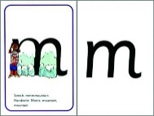
How can I help?
It is really important that pupils use ‘pure sounds’. It is really important to say the sounds clearly to help your child learn them. We say ‘mmmm’ not ‘muh’ and ‘lllll’ not ‘luh’ when teaching the sounds. This really helps children when they learn to blend sounds together to read words.
The link below is for a useful phonics audio guide to all these sounds.
https://www.oxfordowl.co.uk/for-home/reading-owl/find-a-book/read-write-inc-phonics--1/phonics-pure-sounds-video
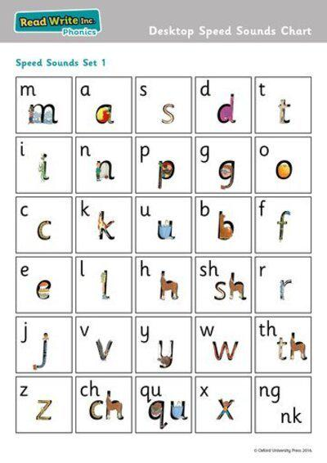
We are working on ‘Set 1 sounds’ in Reception in the Autumn term. Pupils will need to readily recall them using pure sounds and use and apply them to read words.
All of the Set 1 sounds can be found in this flipbook - https://www.oxfordowl.co.uk/api/interactives/29318.html
Pupils can practise these sounds at home using pure sounds.
When reading and sharing books at home, please encourage your child to ‘FRED talk’.

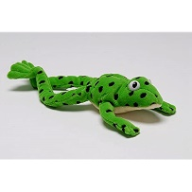

What is Fred Talk?

At Pye Green, we use Read Write Inc. Phonics, teachers will introduce your child to a toy frog called Fred once he or she is ready to start reading words.

Fred can only say the sounds in a word and needs your child to help him read the word. Fred will say the sounds and children will work out the word. For example, Fred will say the sounds c–a–t, and children will say the word cat. This is Fred Talk: sounding out the word.

Further information on phonics at Pye Green, can be found on our school website -https://www.pyegreen.staffs.sch.uk/admin/ckfinder/userfiles/files/Read%20Write%20Inc%20at%20Pye%20Green.pdf

